AWS EC2 Vertical scaling practical 24 Aug 2024

1. Vertical scaling
2. Apply vertical scaling we need to stop the instance

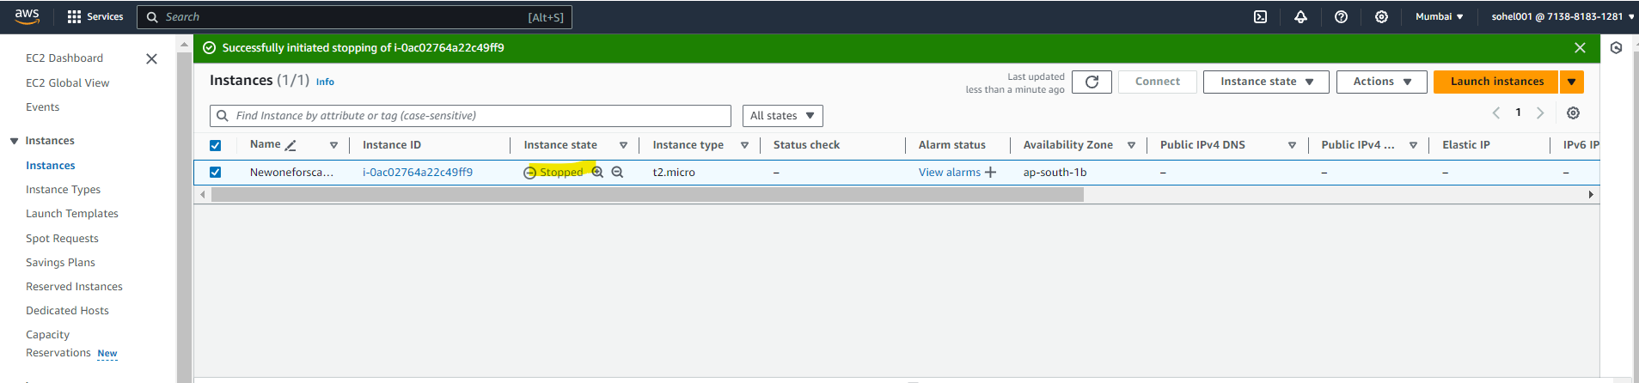

1. Change it to t2.small

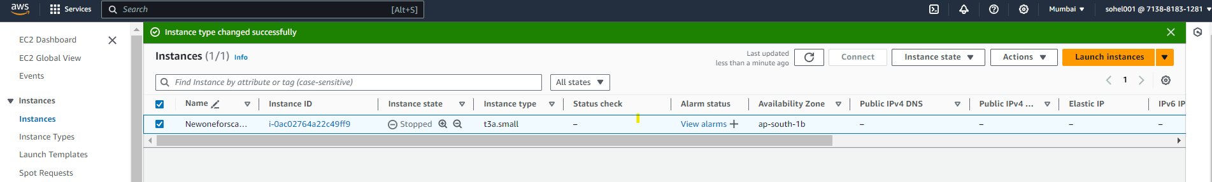

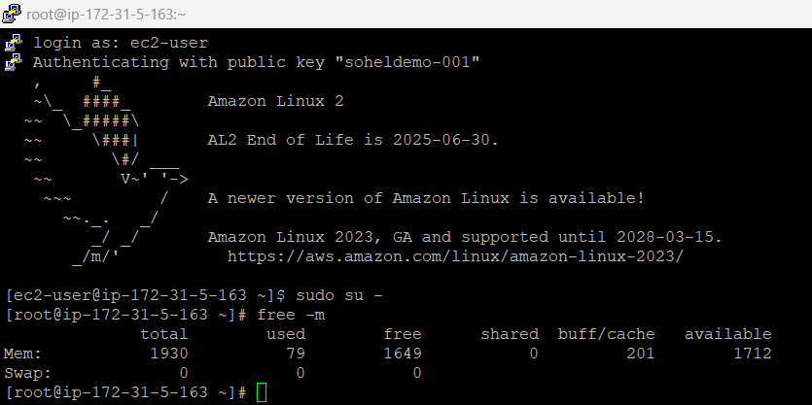

1. Create one volume

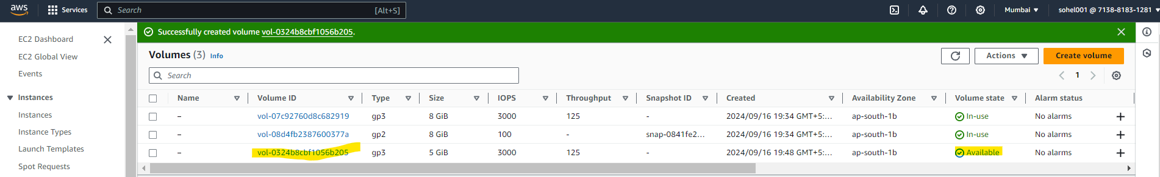

1. Attach EBS volume to instance

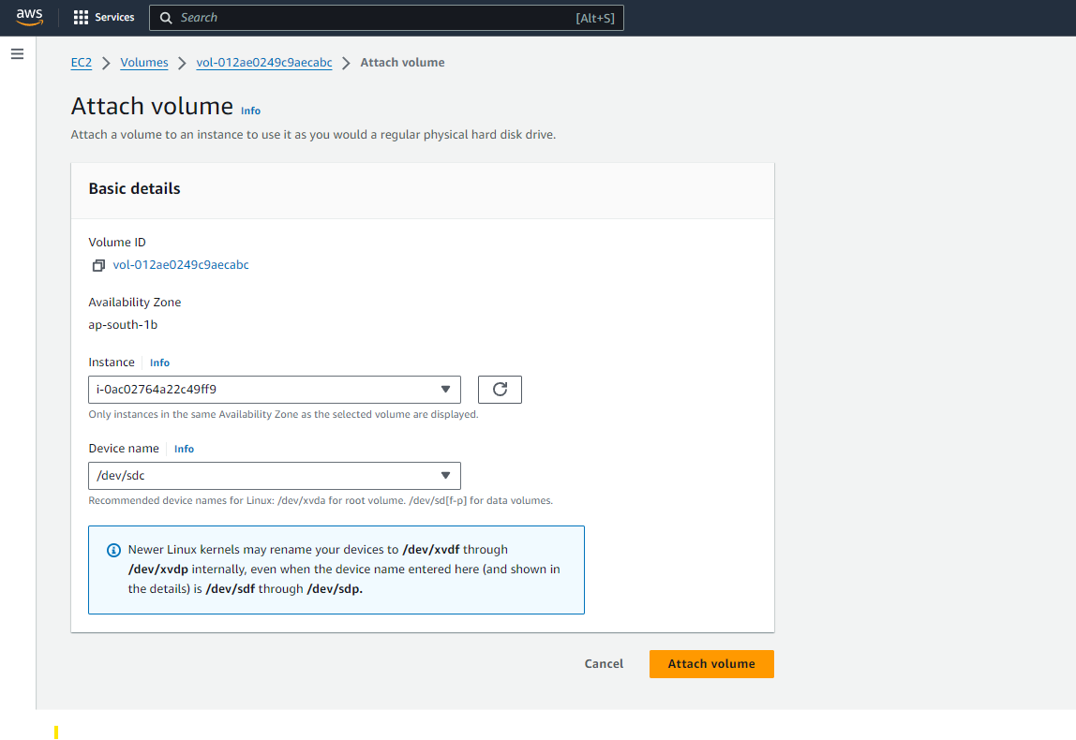

1. Successfully attached volume to the instance

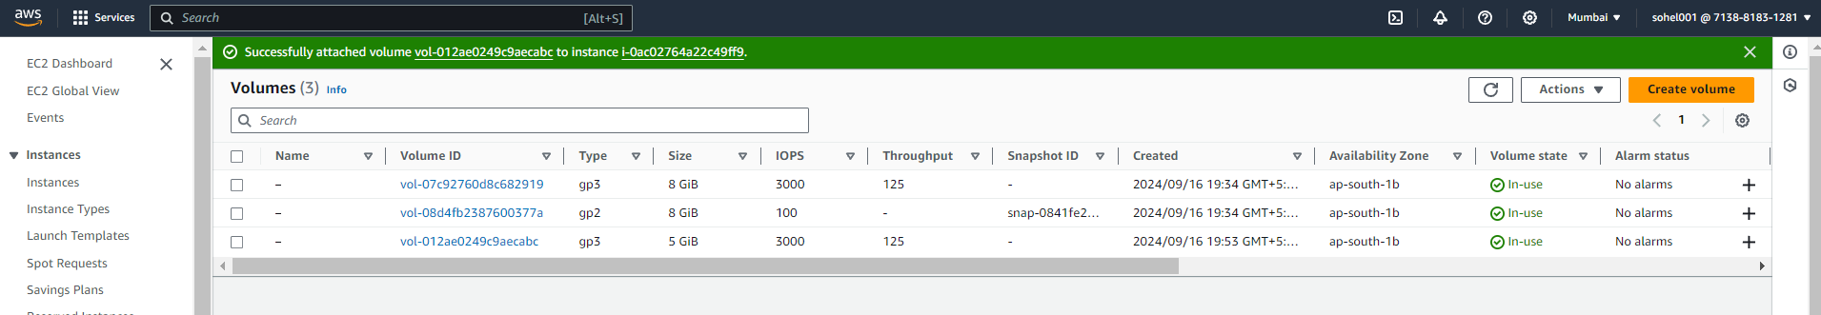

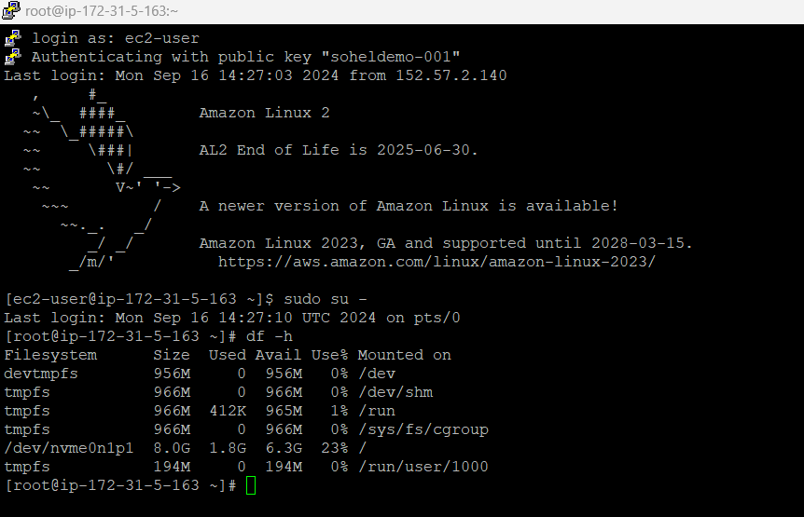

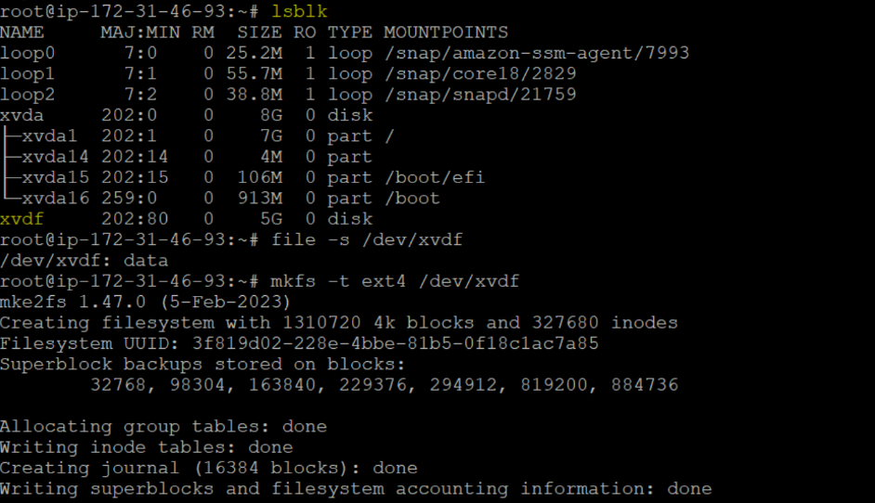

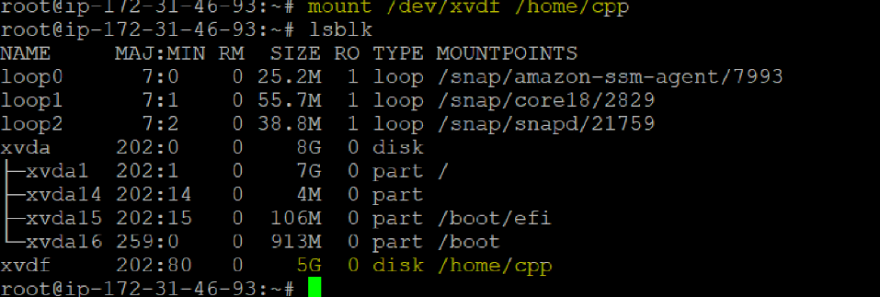

1. Creating one more HDD EBS volume

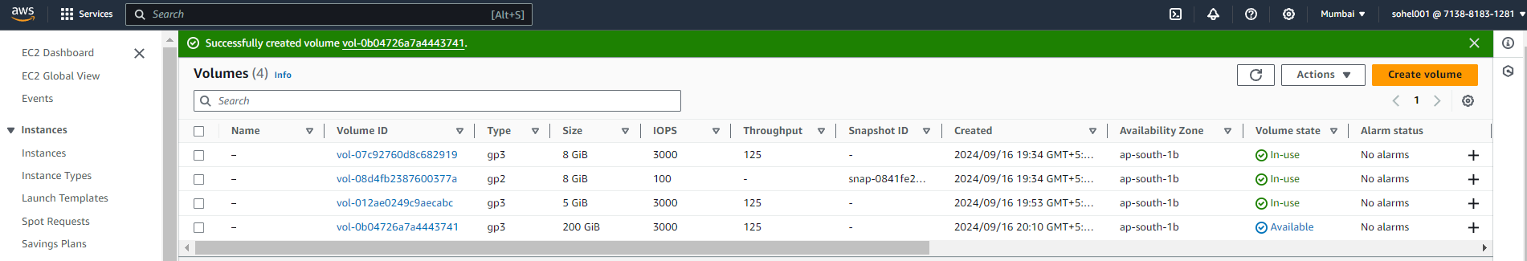

1. Successfully added to the instance

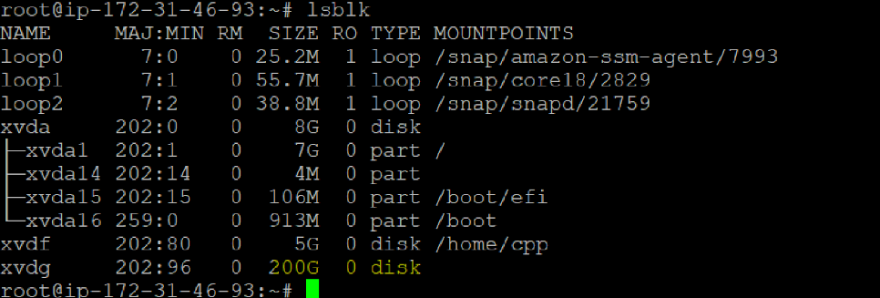

1. Format the new added HDD

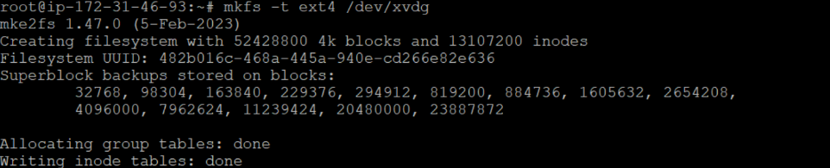

1. Create directory and mount on it

